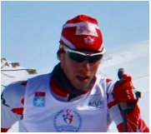
Chris Hamilton

The Year Begins

This spring has brought a lot of changes my way; the most dramatic was my switching Training Centers from Thunder Bay to Canmore, Alberta. This was a long thought out process, but I felt it was the perfect opportunity for me to bring my training to the next level and make the lifestyle transition out onto my own. Living at home and training in Thunder Bay was amazing, but sometimes you just know when its time to move on.
So, I packed up my life and headed West! My spring training life begun as soon as I arrived in Canmore in early May, jumping right into full time training with the Alberta World Cup Academy. This new mega-team is composed of 11 men and 12 women, split into two teams based by gender. This new team structure has functioned very well as we now have a dedicated coach who is focused on the men’s training day-in and day-out.
I didn’t really have much time to settling into my new life and routine in town, as one of the first things this team does in the spring is a big on-snow training camp away from Canmore. This year that meant hopping into the team vans, and driving down to Bend, Oregon!

After the early morning cramming like sardines, it turned out to be an enjoyably scenic driving. We took the mountain pass into Radium, BC and continued south through to the border. It’s amazing how quickly the landscape changes from the high mountains, rolling hills, and finally bare prairie of Idaho. We spent a quick night in Kennewick, Washington and hit the road again early the next morning. We knew we were getting close when a snowy peak started to show on the bare horizon. Well, it seemed close. The snow topped volcanic peak of Mount Bachelor was viewable from probably 170 kilometers out, and it was eerily similar to The Lonely Mountain described in the Tolkien Books.
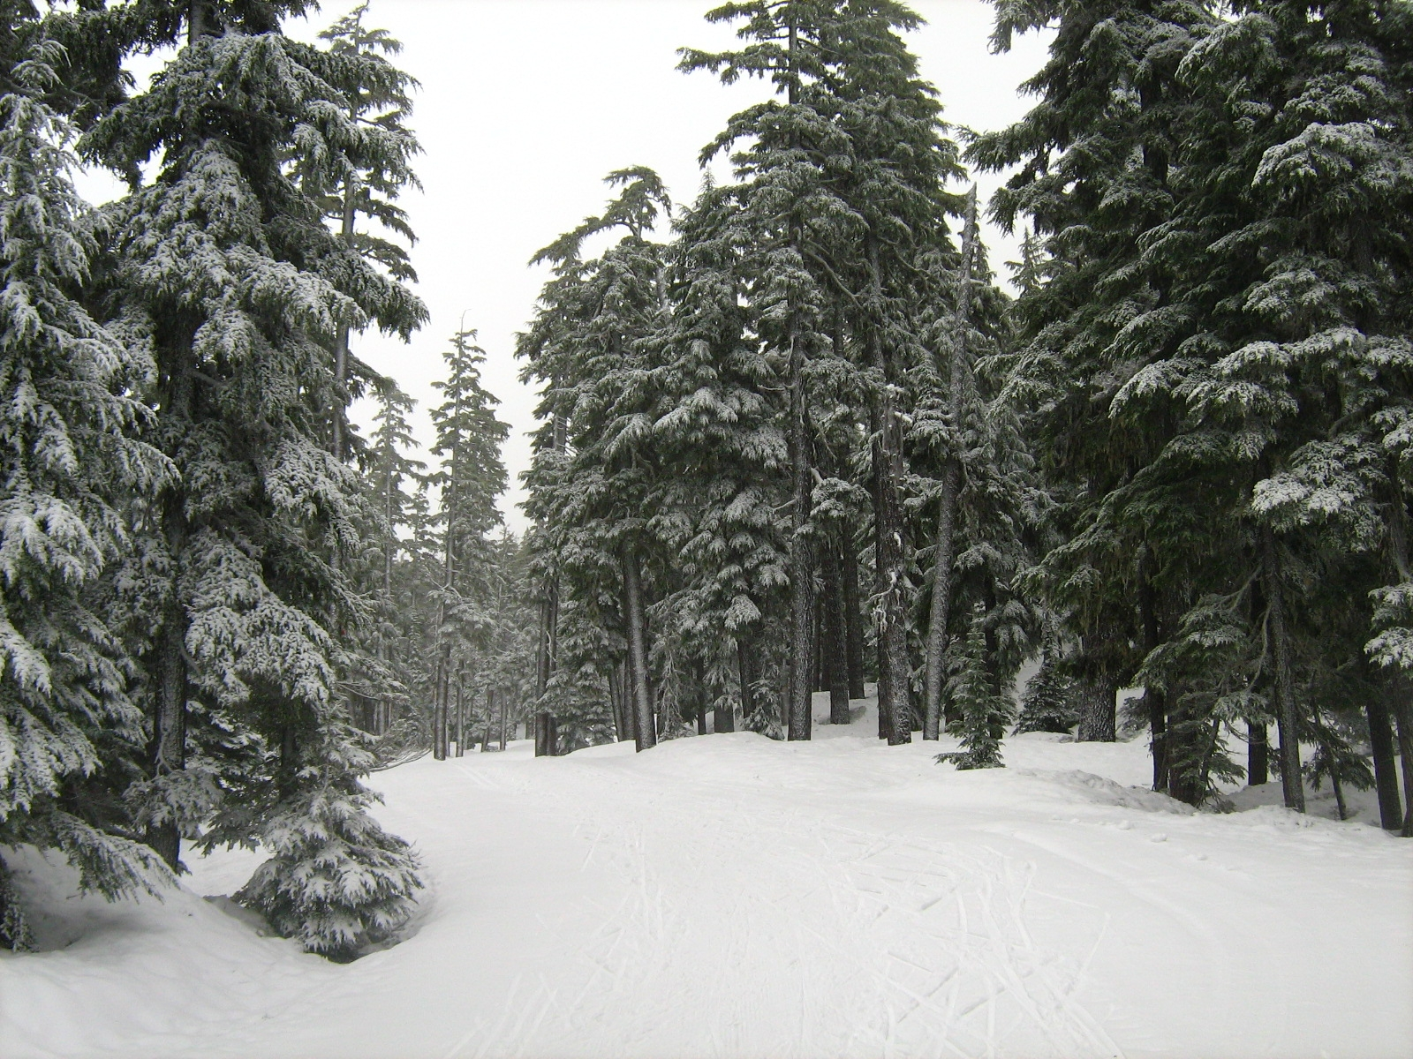
We were greeted in Bend with some of the nicest accommodations I’ve ever stayed in, with a massive house for each team! We settled in quickly to our place, which came complete with BBQ, hot tub and kilometers of running trials out our back door. The team spent the following 10 days enjoying perfect snow conditions a short drive up the mountain, followed by running and gym workouts down in Bend.
It was an amazing, be it somewhat odd sensation, to be skiing in PERFECT snow conditions throughout the last half of May. I benefited greatly from this opportunity to work with my new coaches on snow, addressing technique weaknesses and developing a plan for the rest of the training year.
To top off the greatness of this camp, we were not the only team on Bachelor this spring. The Canadian and American World Cup Teams, both National Senior Development Teams, both Biathlon National Teams plus a number of Elite American Club teams all made the trek out to form an enormous spring training extravaganza! The mountain likely had 80% of all the elite skiers in North America! This provided an invaluable opportunity to watch better skiers and learn from the group.
However, my body took quite the shock to the system by jumping into full training mode, and I ended up developing a cold by the last portion of the camp. I was quickly quarantined away from the other athletes, and my training regiment cut down. After a couple days to rest a bit, I was able to finish the camp off with some shorter workouts. That’s just how it goes sometimes, a little bad with lots of good.
It didn’t seem long before the camp came to a close, and we once again packed the vans up and hit the road. This time we drove like madmen to punch out a 14 hour / 1200km single travel day back to Canmore. Everyone was completely spent by the time we rolled into town and put an end to the first camp of the year.

I want to take this chance to thank everyone for their words of encouragement over the last few months as I prepared to move away from Thunder Bay and on to these new opportunities. The support you have all shown has made this transition smooth and I’m looking forward to all the new changes that are happening in my life!

Cheers!
Chris

Unit 19, 1201 Railway Ave. Canmore, AB T1W 1R4 Canada Phone: 403-679-8539
Email: chrishamilton117@gmail.com Website: Under-construction
Blair Schoales
Medical Professional Corporation

